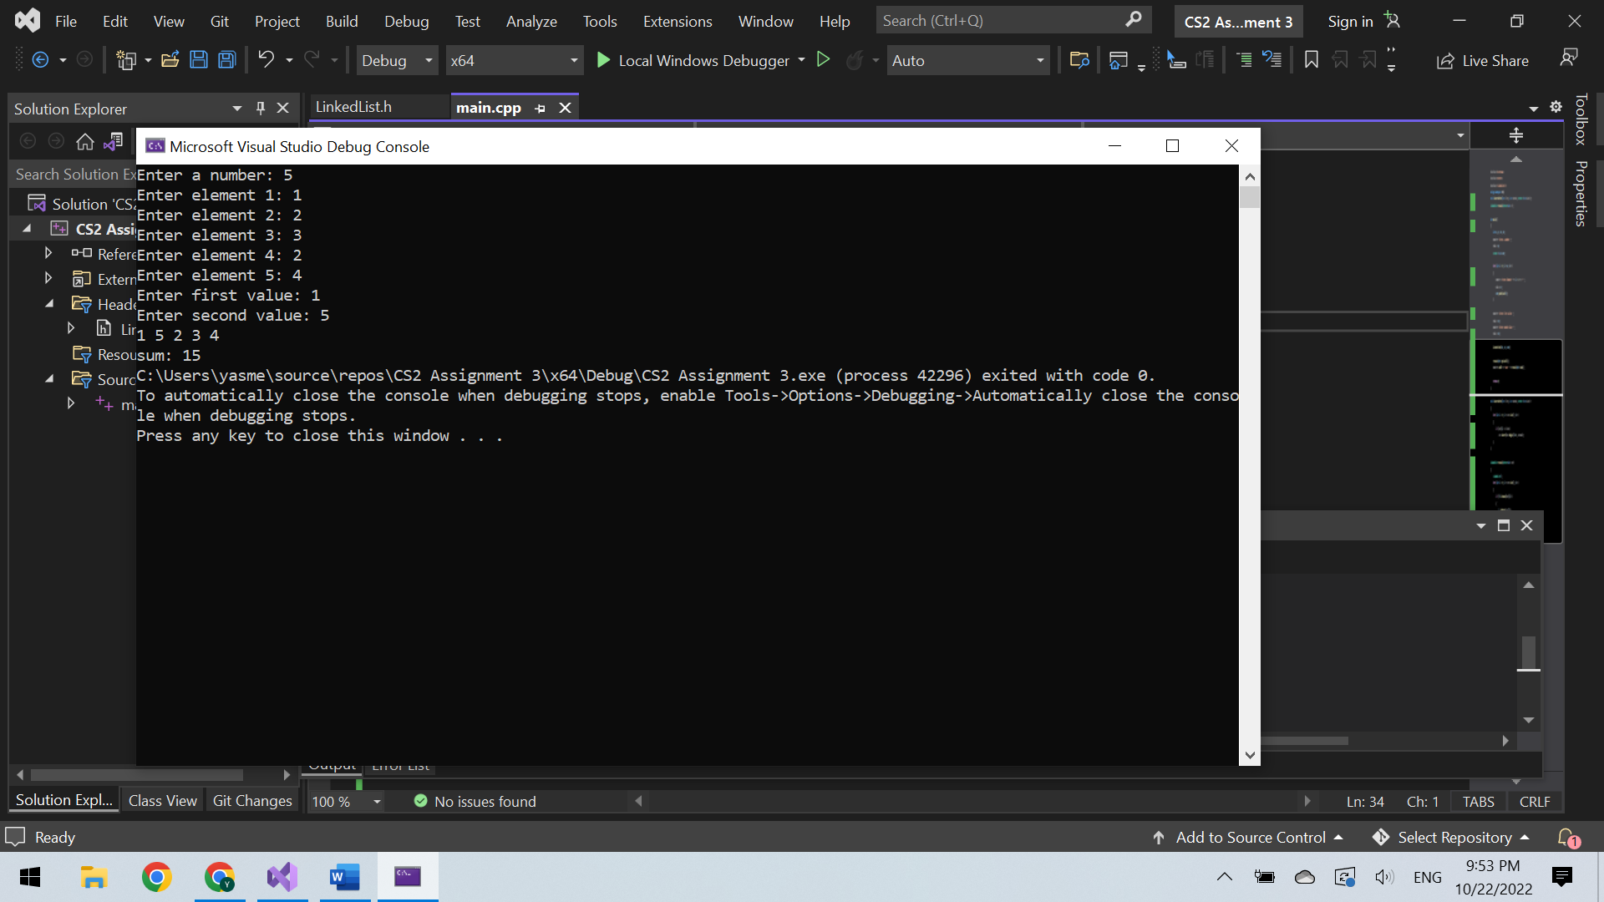

The user first enters the number of integers he would like to input (size of the vector = 5), and the integers themselves (elements of the vector = 1,2,3,2,4). Then, the code pushes back these integers into a vector. After that, the user is asked to enter 2 values where the first (=1) is the position after which the second (=5) should be inserted. Then, the code creates a linked list containing each element of the vector only once without any repetition (= 1,5,2,3,4), prints this list, and calculates the sum of the values in the list (=15).

Reference for the linked list: <https://www.youtube.com/watch?v=nyIF45QKX4k>